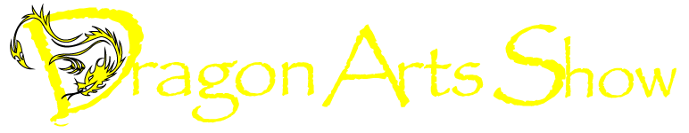
Ceramics by Dove Govrin

Exhibition October 4 to December 19th, 2012
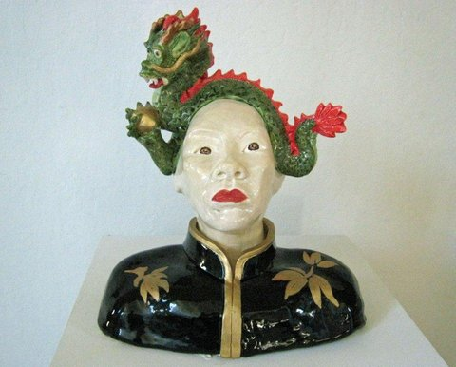

College of Marin Emeritus Center
Student Services Building, Room 146
835 College Ave, Kentfield, CA
Hours M-F 9:30-3:30pm

Opening reception: Thursday Oct 18, 5:30-7:30pm
Dragon Qigong Demo at 6:45pm

Wild Goose Qigong Demonstration:
Thursday Nov 15th 7pm; Open gallery
and Dragon Arts sale 6-8pm

Exhibit sponsored by Emeritus Students of College of Marin

